CAR PRICE ANALYSIS & PREDICTION USING POWER BI

ABSTRACT
The automobile industry is one of the most dynamic and competitive markets, where pricing plays a crucial role in consumer decision-making and business profitability. This project, titled “Car Price Analysis & Prediction using Power BI,” focuses on analyzing historical car data to understand the factors influencing vehicle prices. Using Power BI, the dataset was cleaned, transformed, and analyzed to uncover trends related to brand, fuel type, mileage, transmission, condition, and year of manufacture. The project demonstrates the effective use of Power BI tools such as Power Query Editor, DAX functions, and interactive dashboards to convert raw data into meaningful insights that support data-driven decision-making.

1. INTRODUCTION
In recent years, the availability of large volumes of data has transformed the way businesses operate. The automotive industry, in particular, generates vast amounts of data related to vehicle specifications, pricing, customer preferences, and market trends. Analyzing this data manually is inefficient and prone to errors. Hence, business intelligence tools like Power BI are used to process and visualize data efficiently.

This project aims to analyze car price data and identify the major factors that affect vehicle pricing. By leveraging Power BI’s powerful visualization and analytical capabilities, the project provides a clear and interactive dashboard that helps stakeholders understand pricing patterns and market behavior. The analysis is useful for car dealers, manufacturers, buyers, and analysts to make informed decisions.

2. OBJECTIVES OF THE PROJECT

The objectives of this project are as follows:

- To analyze historical car pricing data using Power BI

- To clean and transform raw data using Power Query Editor

- To apply DAX functions for calculating key performance indicators

- To identify the relationship between car price and factors such as brand, fuel type, mileage, transmission, and condition

- To design an interactive and user-friendly Power BI dashboard

- To generate meaningful insights and business recommendations

3. DATASET DESCRIPTION
The dataset used for this project was collected from Kaggle – Car Price Prediction Dataset. It contains structured data related to various cars sold across different years and brands.
Dataset Features:
- Brand
- Model
- Manufacturing Year
- Price
- Mileage
- Fuel Type (Petrol, Diesel, Electric, Hybrid)
- Transmission Type (Manual, Automatic)
- Vehicle Condition (New, Used, Like New)

The dataset contains approximately 2,000 records and includes 7 unique car brands. The diversity of features makes the dataset suitable for detailed exploratory and comparative analysis.

4. DATA CLEANING & TRANSFORMATION
Data cleaning and transformation are critical steps in any data analytics project. In this project, Power Query Editor was used extensively to prepare the dataset for analysis.

Data Cleaning Steps:
- Removed duplicate records to ensure data accuracy
- Standardized categorical fields such as brand, fuel type, and transmission
- Converted data types to appropriate formats (numeric, text, date)
Data Transformation Steps:
- Created a new column for Price Category (Low, Medium, High)
- Grouped mileage values for better comparison
- Renamed columns for clarity and readability

These steps ensured that the dataset was clean, reliable, and ready for analysis.

5. DAX FUNCTIONS IMPLEMENTED
To calculate important metrics and enhance analytical capabilities, several DAX (Data Analysis Expressions) functions were used.

List of DAX Functions Used:
- SUM() – To calculate total revenue and total mileage

- AVERAGE() – To calculate average car price and mileage

- COUNT() – To find the total number of cars

- DISTINCTCOUNT() – To calculate the number of unique brands

- CALCULATE() – To perform context-based calculations

- IF() – To classify price categories

- FILTER() – To apply conditional logic

- ALL() – To ignore filters for overall comparison

- DIVIDE() – To avoid division errors

- YEAR() – To extract year for trend analysis

These functions helped in generating dynamic KPIs and improving dashboard performance.
DAX QUERIES
- Total Revenue = SUM('car_price_prediction_'[Price])

- Total Cars = COUNT('car_price_prediction_'[Car ID])

- Unique Brands = DISTINCTCOUNT(car_price_prediction_[Brand])

- Car Age = YEAR(TODAY()) - car_price_prediction_[Year]

- Average Price = AVERAGE('car_price_prediction_'[Price])

- High Price =
IF(AVERAGE('car_price_prediction_'[Price]) > 50000, "High", "Normal")

6. DASHBOARD DESIGN & FEATURES
The Power BI dashboard was designed to be interactive, visually appealing, and easy to understand.
Dashboard Highlights:
- KPI cards showing Total Cars, Total Revenue, Average Price, Unique Brands, and Average Mileage

- Brand-wise average price comparison

- Fuel type distribution analysis

- Vehicle condition-wise car count

- Transmission preference comparison

- Year-wise price and sales trends

- Mileage versus price analysis

Interactivity:
- Slicers for Year, Brand, and Fuel Type

- Cross-filtering between visuals

- Dynamic updates based on user selection

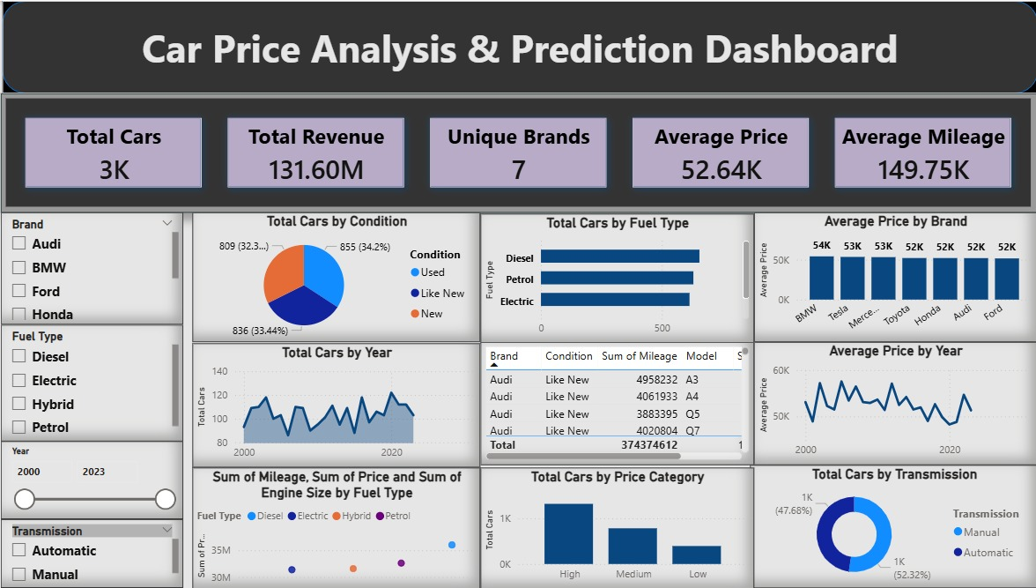

7. KEY INSIGHTS & ANALYSIS
- Premium brands such as BMW and Tesla command higher prices

- Diesel and Petrol vehicles dominate the market

- Automatic transmission cars are more popular than manual

- New and Like New cars contribute significantly to revenue

- Electric vehicles show better price-to-mileage efficiency

- Car prices show moderate fluctuation over different years

8. BUSINESS RECOMMENDATIONS
- Based on the analysis, the following recommendations are proposed:

- Focus on premium and automatic vehicles for higher profitability

- Promote electric vehicles due to future demand and sustainability

- Mileage should be a key pricing factor for used cars

- Maintain competitive pricing in medium and high price categories

- Use data-driven insights for inventory planning

9. CONCLUSION
The Car Price Analysis & Prediction using Power BI project demonstrates how business intelligence tools can transform raw data into actionable insights. Through effective data cleaning, DAX calculations, and interactive dashboards, the project provides a comprehensive understanding of car pricing trends. The analysis supports informed decision-making and highlights the importance of data analytics in the modern automotive industry.

